*Heaven’s Light is Our Guide*

**Rajshahi University of Engineering & Technology**

Department of Electrical & Computer Engineering

Course No: ECE 4124

Course Title: Digital Signal Processing Sessional

Experiment No: 01

Experiment Name: Convolution of Two Signals

|  |  |
| --- | --- |
| **Submitted by:**  Name: Md. Zayed Al Masud  Roll: 1810016  Date of Experiment: 19. 03. 2023  Date of Submission: 03. 05. 2023 | **Submitted to:**  Hafsa Binte Kibria  Lecturer,  Dept. of ECE |

**Theory:**

Convolution is a mathematical way of combining two signals to form a third signal. It is an important technique in Digital Signal Processing. Convolution is a formal mathematical operation, just as multiplication, addition, and integration. Addition takes two numbers and produces a third number, while convolution takes two signals and produces a third signal.

The convolution of two signals $x\left(n\right) and h(n)$ is given by,

$$y\left(n\right)=x\left(n\right)*h\left(n\right)= \sum_{k= -∞}^{∞}{x\left(k\right) h\left(n-k\right)}$$

Or,

$$y\left(n\right)=h\left(n\right)*x\left(n\right)=\sum_{k= -∞}^{∞}{h\left(k\right) x\left(n-k\right)}$$

Convolution satisfies,

(i) Commutative Law: $h\left(n\right)*x\left(n\right)=x\left(n\right)*h\left(n\right)$,

(ii) Associative Law: $\left[x\left(n\right)*h\left(n\right)\right]*h_{1}\left(n\right)= x\left(n\right)*[h\left(n\right)*h_{1}\left(n\right)]$ and

(iii) Distributive Law: $x\left(n\right)*\left[h\left(n\right)+h_{2}\left(n\right)\right]=x\left(n\right)*h\left(n\right)+x\left(n\right)*h_{2}\left(n\right)$

**Code:**

x = [1, 2, 3, 4];

h = [4, 4, 3, 2];

L = length(x);

M = length(h);

N = L + M - 1;

cv = zeros(1,N);

x1 = [x, zeros(1,L)];

h1 = [h, zeros(1,M)];

for i = 1:N

for j = 1:M

if (i-j+1) > 0

cv(i) = cv(i) + x1(j)*h1(i-j+1);

end

end

end

disp(cv)

subplot(3,1,1); stem(x); xlabel('n');

ylabel('x[n]'); title('First Signal');

subplot(3,1,2); stem(h); xlabel('n');

ylabel('h[n]'); title('Second Signal');

subplot(3,1,3); stem(cv); xlabel('n');

ylabel('Y[n]'); title('Convoluted Signal');

**Output:**

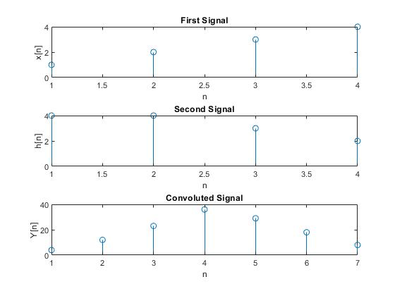

Fig 1.1: Convolution of Two Signals

**Conclusion:**

In this experiment, convolution was implemented without using any built-in function and the result was plotted.